Challenged Athletes Foundation
2019 Grant Application
Step-by-Step Instructions

This resource will walk you through the entire 2019 CAF Grant
Application process, step by step. We hope you will find it helpful!

Click on 2019 Grant Application link

2019 CAF Grant Application Link:
https://webportalapp.com/sp/cafgrant

The link can also be found on the CAF website:
www.challengedathletes.org/grants

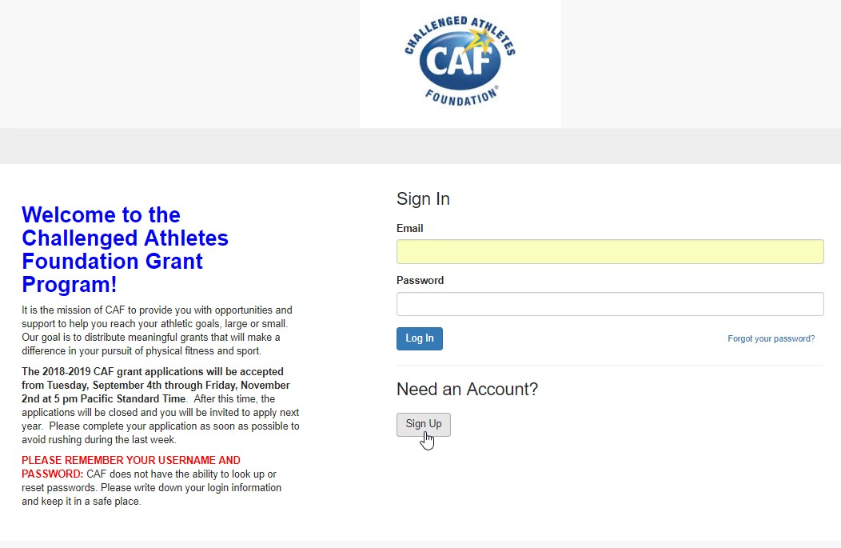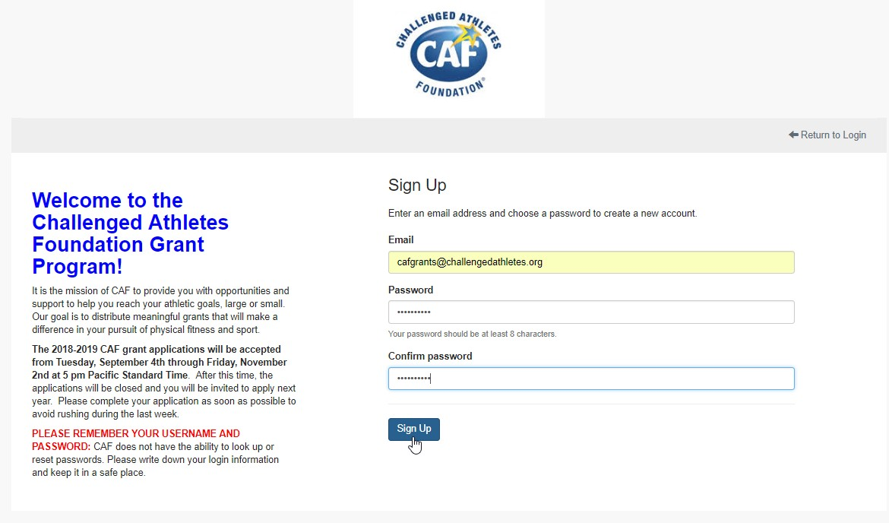Create an Account
Type in your primary, updated email address, and create a password.
NOTE: CAF does not have the ability to reset passwords, so make sure you write your login information down somewhere so you do not forget it!
Click the “Sign Up” button to create your account. All 2019 grant applicants must create a new account. Read the text on the left hand side of the page carefully!

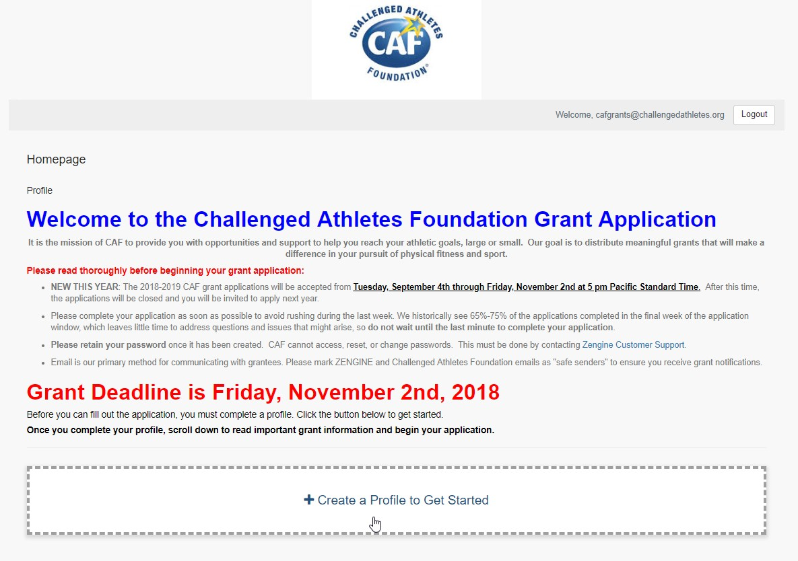2019 Grant Application Homepage
Note the new deadline!
Before you can begin the application, you must create a profile. Click the button to begin.
Once you log in, you will see this page.
This is the application homepage.
Please read all information carefully!

Create Profile
Click “Save” once completed
to move on to application.
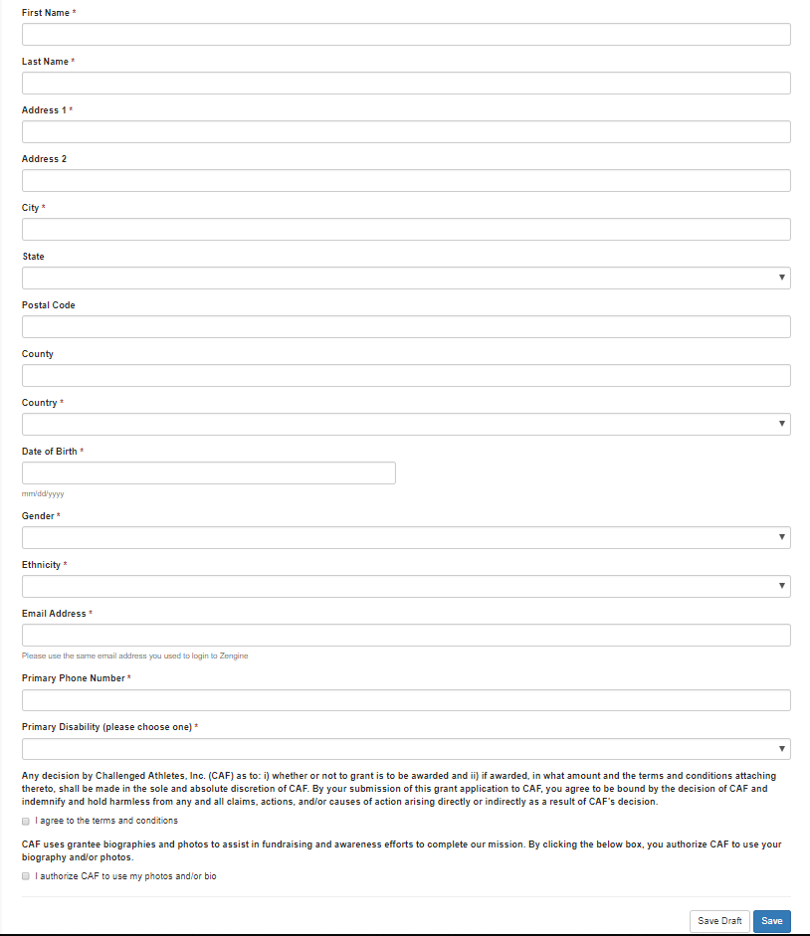
Fill out all fields with grant applicant’s information:
Please read the Terms & Conditions. Click buttons to authorize CAF to use your photos & bios.
Important: Make sure to type in the SAME email address you used to log in.

Return to Homepage
To view profile, click the eye icon. To edit, click the pen & paper icon.

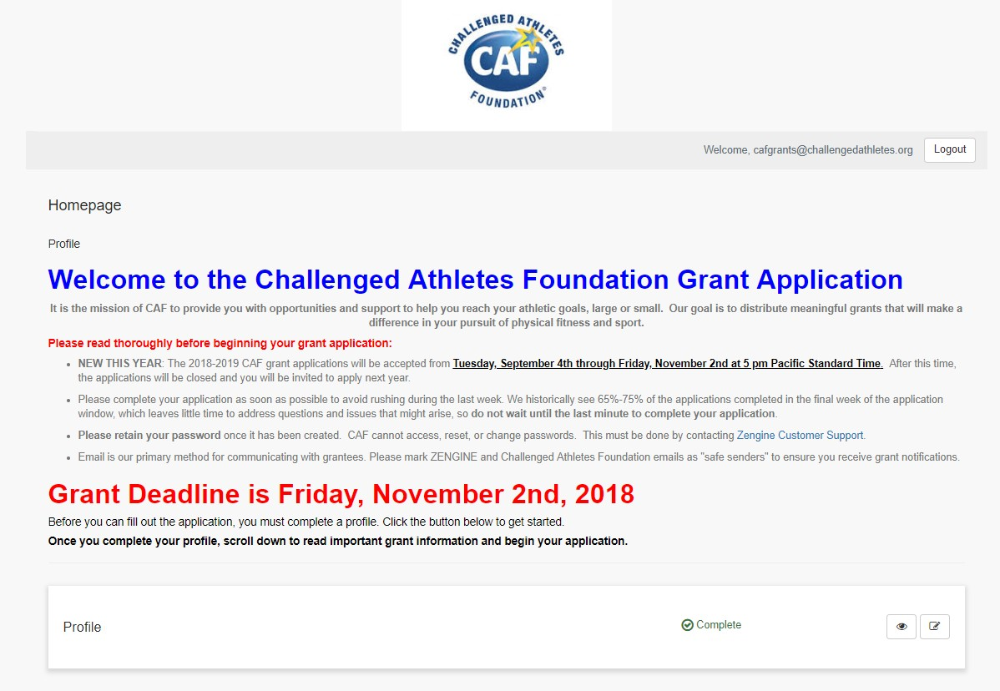
Once you have completed your profile, you’ll be taken back to the homepage.
You’ll see that the Profile
section has now been marked “Complete”, and the grant application has
been unlocked.
Scroll down on homepage to read important application information
(Next page)

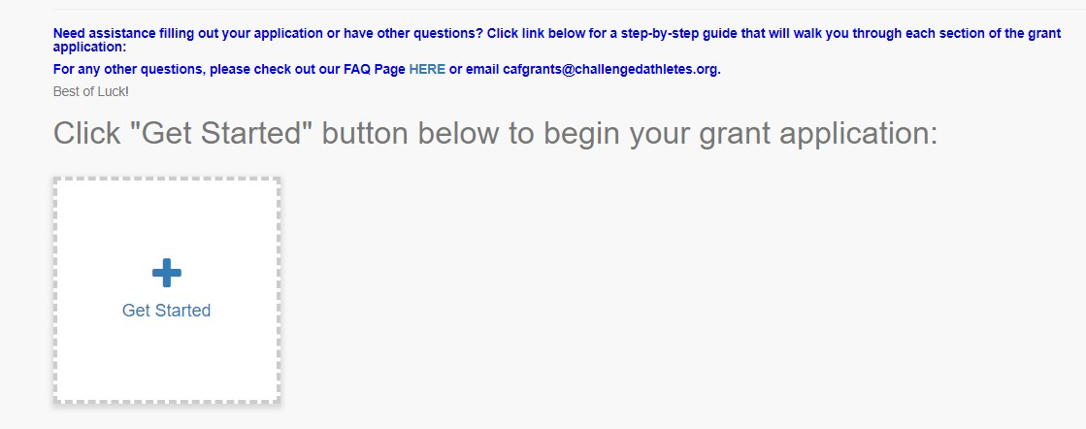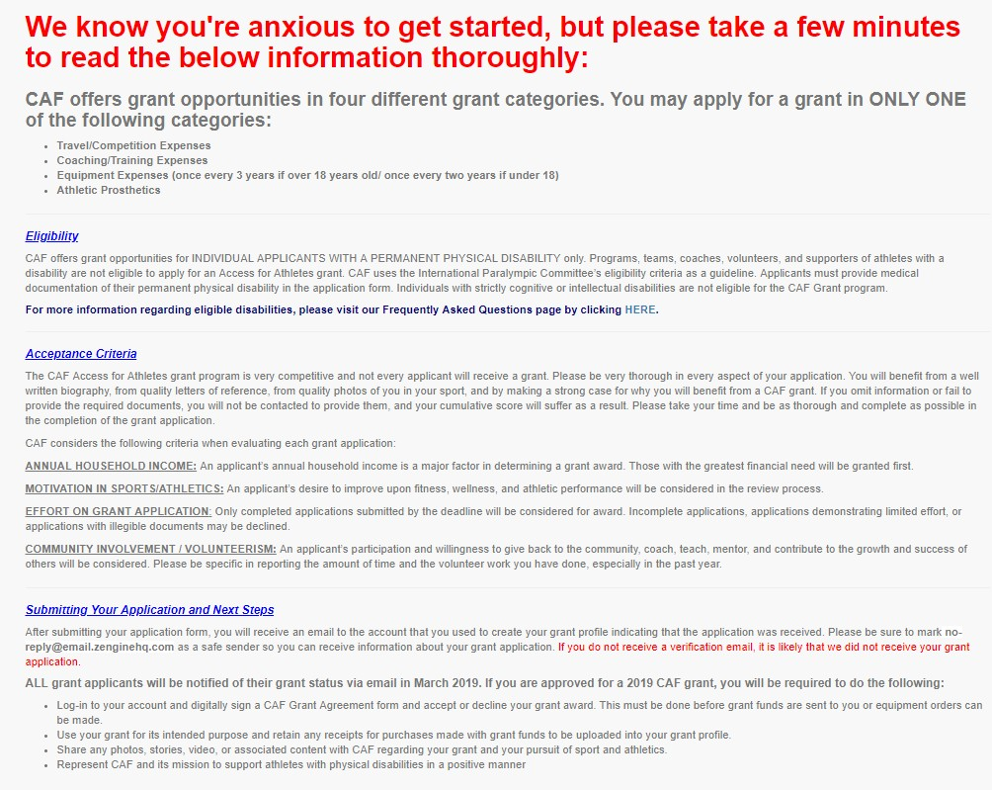Application Information, Get Started
Once you’ve read all the important information, scroll down and click the “Get Started” button.
*Note: If you save your application and log back in, the button will no longer read “Get Started”- it will instead have your name on it.

Read all information thoroughly!

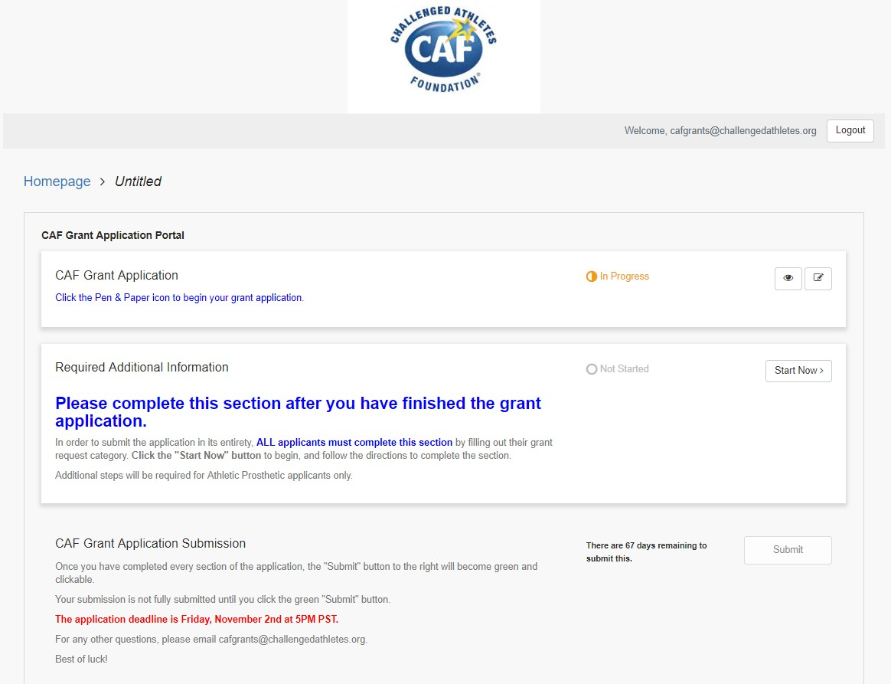Grant Application Portal Page
You will now be taken to the CAF
Grant Application Portal. You’ll see the CAF Grant Application status as “In Progress”- this is because you completed your profile.

Click the Pen & Paper icon to begin filling out the application portion.

Once you’ve completed the application, then you can move on to the Required Additional Information Section.

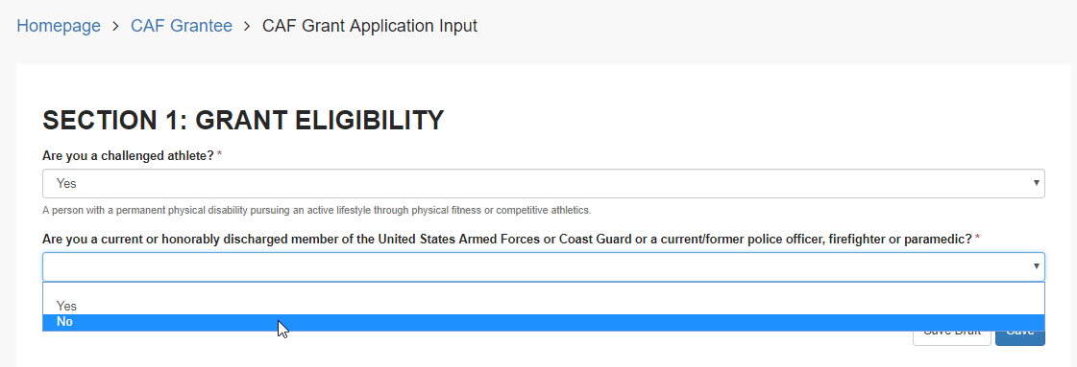CAF Grant Application
Note: If you answer “Yes” to the second eligibility question, you are eligible for the Operation Rebound grant and will be redirected.
Applicants will be prompted to answer two eligibility questions. Once
answered, the rest of the application will be unlocked for completion.

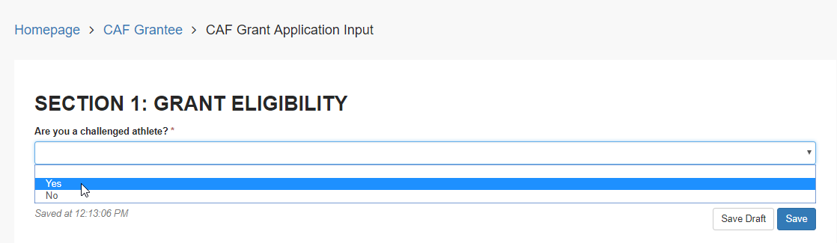

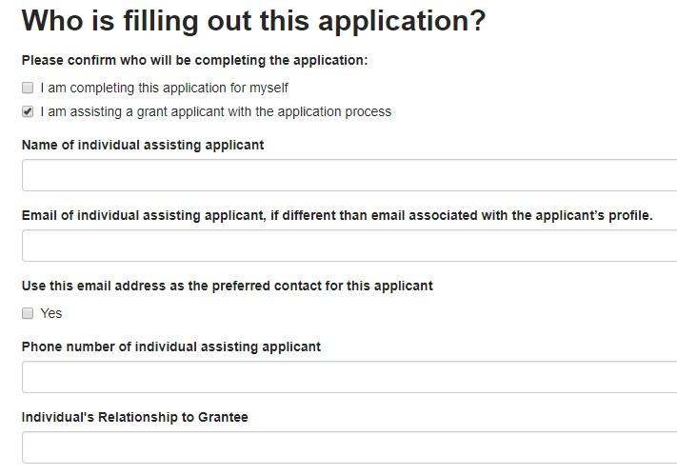Who is filling out this application?

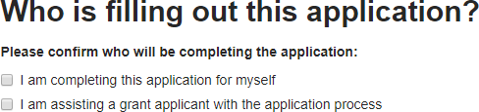
If YOU are the grantee and are filling out the application for yourself, please click the first option, “I am filling the
application out for myself”. This is all you
will need to do for this section.

If you are filling out the application FOR a grantee or ASSISTING a grantee, please click the second option, and then fill out all the required information. This will help us determine who is the grantee and who is the point of contact.

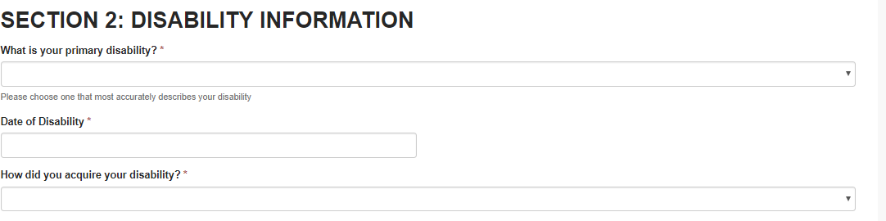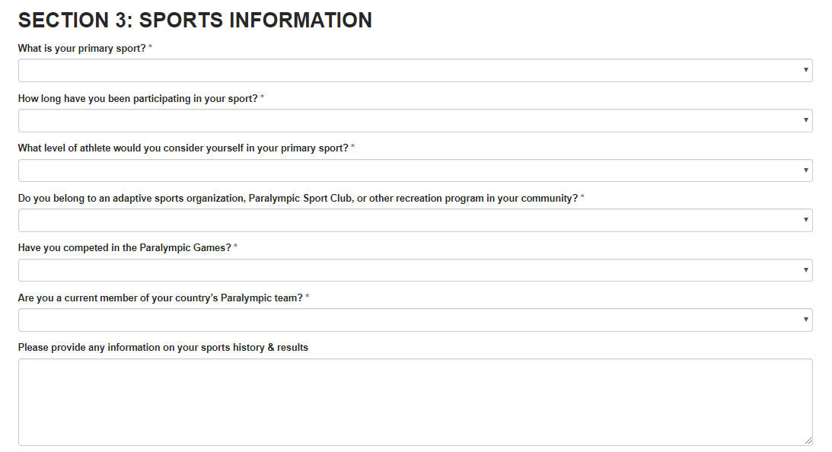Application Sections 2 & 3

Fill out all information in sections 2 & 3

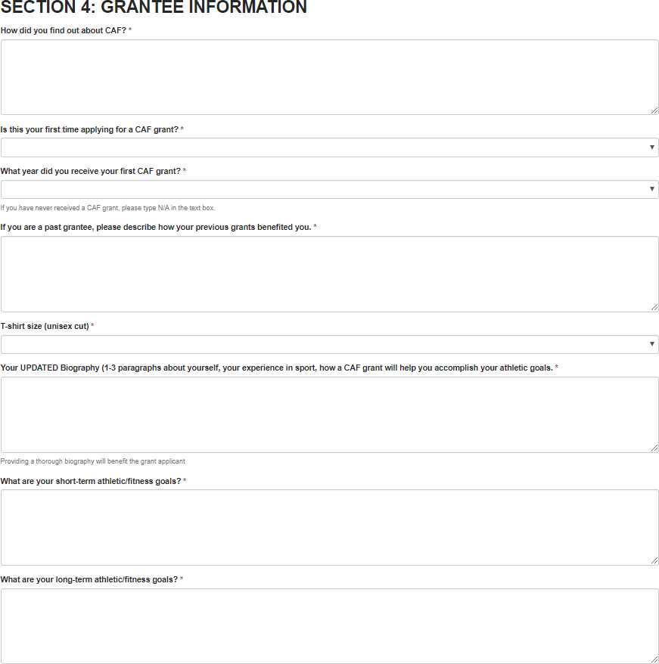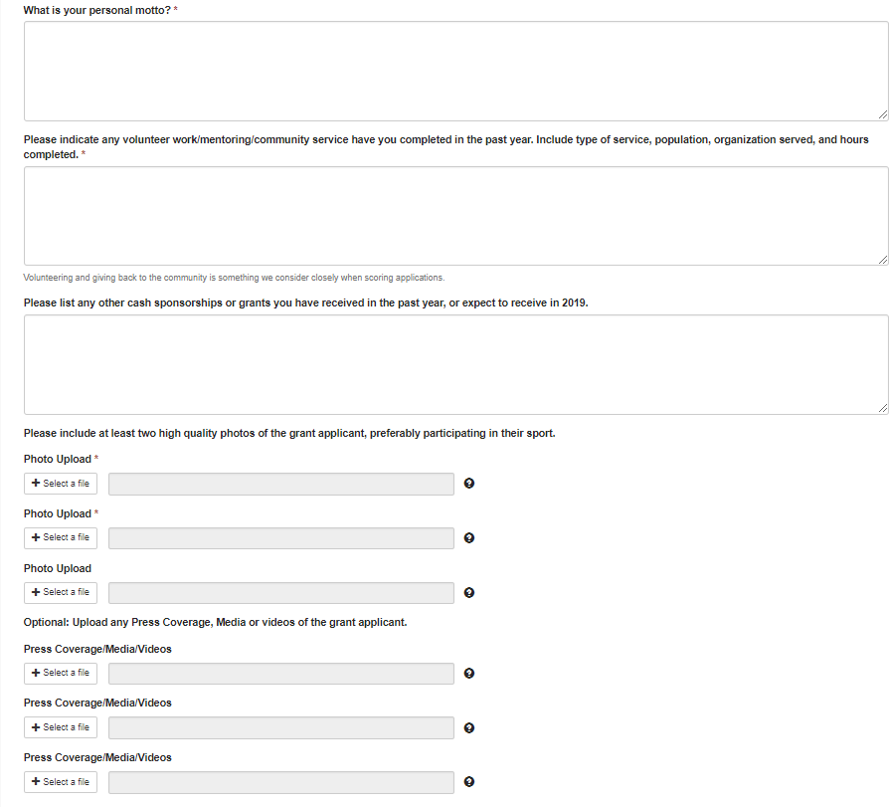Section 4: Grantee Information
Section 4 allows our Grants Team to get to know the grant applicant a little better. Take your time on this section- Applicants will benefit from writing thorough answers to questions and prompts.

We require at least two high resolution photos of the applicants.
Please upload in JPEG form if possible.

Section 5: Supplemental Information
Financial Information

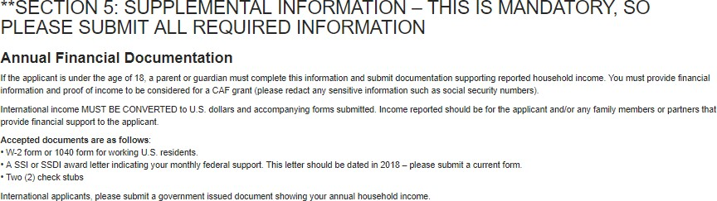

The Financial Information portion of the application is extremely important. We require proof of income in order to ensure that we are helping as many applicants as possible, starting with those who have the greatest need for financial assistance. Please read this section thoroughly. Failure to provide necessary financial documentation could prevent an applicant from receiving a grant.

Section 5: Supplemental Information
Financial Information - continued

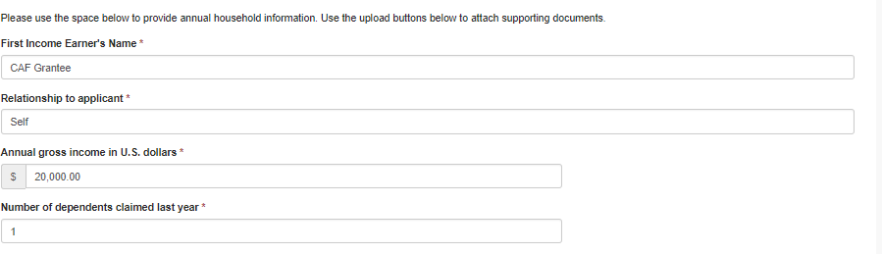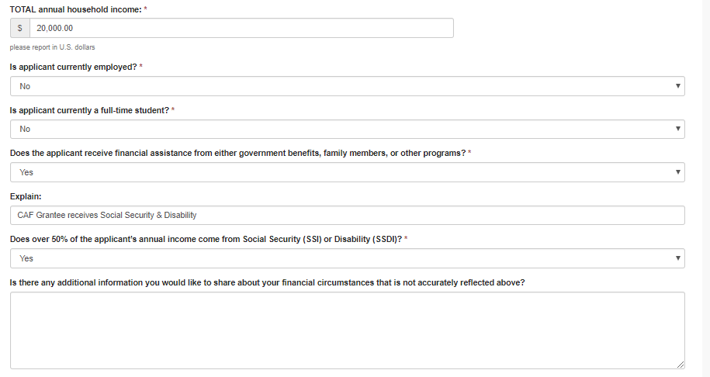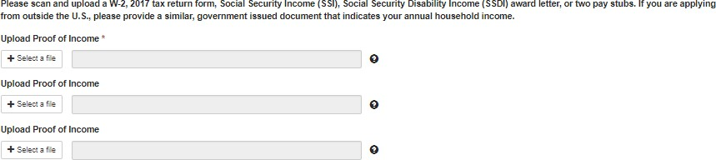
Fill out all applicable fields. Please fill in financial information for all incomes that support the grant applicant. Total household income should be the sum of all incomes that support the applicant. Please also indicate if applicant is employed, in school, or if there is anything else we should
know about the applicant’s financial circumstances.
Upload Proof of Income(s). Be sure to omit/hide social security numbers or other sensitive information from the documents you upload.

Section 5: Supplemental Information
Medical Information

CAF requires applicants to provide proof of disability. Please upload a letter or documentation from your medical professional (doctor, nurse, physical therapist, prosthetist, etc.), as well as fill in the medical professional’s name and title in the appropriate places. This letter/documentation can be the same one you’ve used on prior grant applications, and does not need to be updated annually.

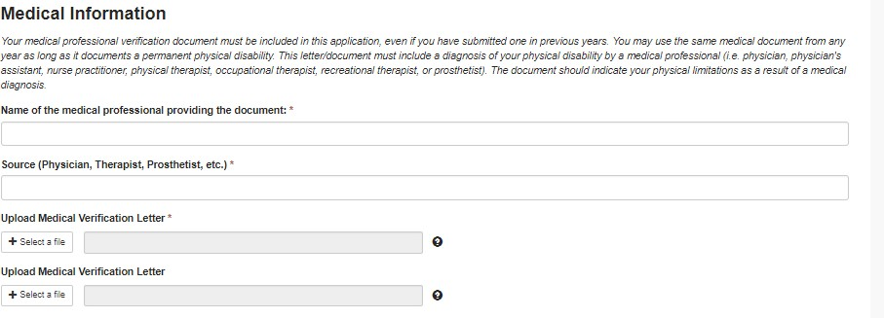

Section 5: Supplemental Information
Personal Letter of Reference

CAF requires applicants to provide ONE letter of reference from someone who knows them well and can share
with the Grants Team more about the applicant’s character, motivation, and why & how they would benefit from
a CAF grant. Please fill in their name, as well as their relationship to the applicant.
This reference letter MUST be current and cannot be the same letter used in past applications.
An applicant will benefit from a well-written personal reference.

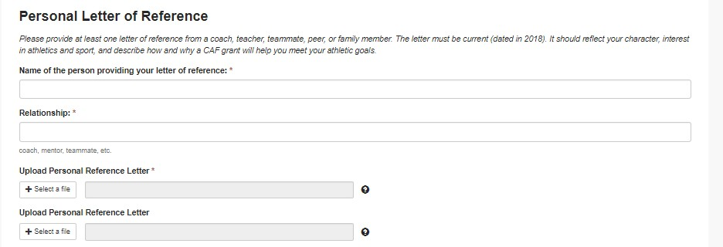

Section 6: Grant Request

Please select your primary sport/physical activity from the dropdown list.
Then, choose your Grant Request category from the dropdown list

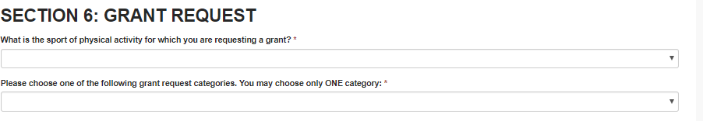

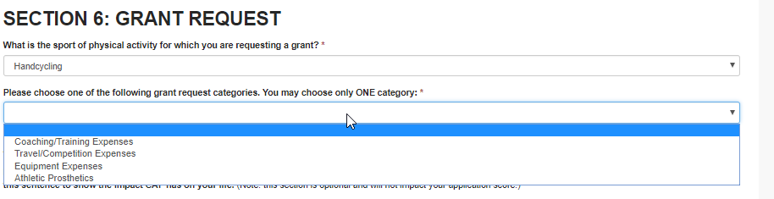

Section 6: Coaching & Training Grant Request

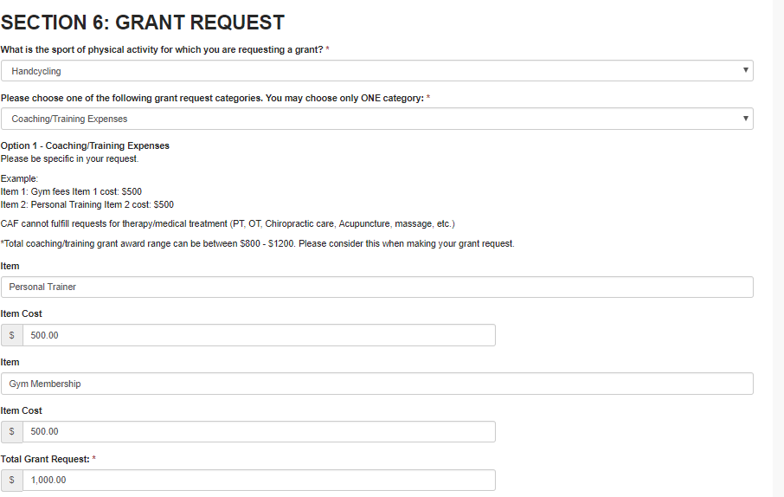
If you select a Coaching & Training grant, please fill out the “Item” you’re requesting (i.e. Personal Trainer, Gym Fees, Coaching Lessons etc.). Then, include the approximate cost of the item.

You can select up to two “items” in your grant request, however, only one item is required. Fill in the total amount you are requesting in the “Total Grant Request” box.

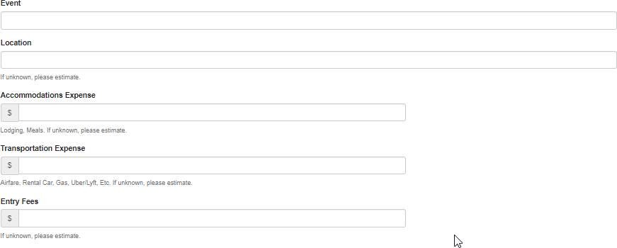Section 6: Travel & Competition Grant Request
Transportation Expenses can include airline tickets, rental cars, gas, ubers, etc.
Accommodations Expenses can include hotels or other accommodations, and meals. Please note that if the grantee is under 18, the grant funds can be used to support the grantee and ONE accompanying adult.

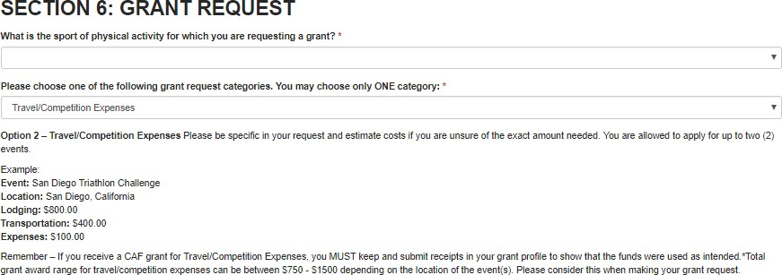
If you select a Travel & Competition grant, please fill out the event you’re requesting funding for. Include the location, the approximate lodging, transportation, and/or the entry fee expenses. If you don’t know the exact amounts for these sections, please do some research and make your best approximate guess.

You can request for funding for up to two events, but please note that grant requests typically don’t exceed $1,500.
Fill in the total amount you are requesting
in the “Total Grant Request” box.

Section 6: Equipment Grant Request

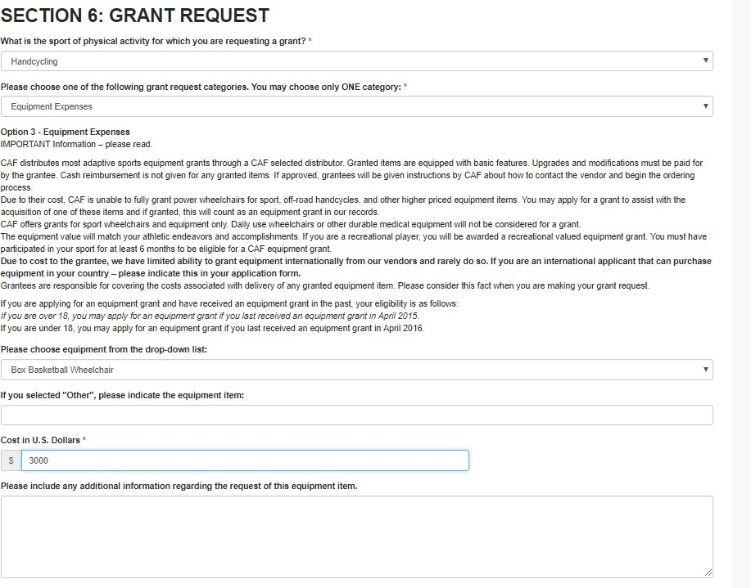If you select an Equipment grant, please choose your equipment from the dropdown list. If your desired equipment is not listed, please select “Other” and fill in additional information in designated text box.

If you don’t know the exact amount of the equipment, please do some research and make your best approximate guess. We recommend applicants research the products to make sure they are selecting the best equipment for their athletic pursuits and ability level.

CAF works with a variety of quality equipment vendors. If approved, CAF Grantees will receive instructions about how to order equipment through CAF’s preferred vendor. The vendor will then bill CAF for the amount of the basic equipment. Any upgrades, enhancements, or modifications will be the grantee’s responsibility to pay. Unless vendor indicates otherwise, grantees are also responsible for the shipping costs of the equipment.

Please read this section thoroughly for more information.

Section 6: Prosthetic Grant Request

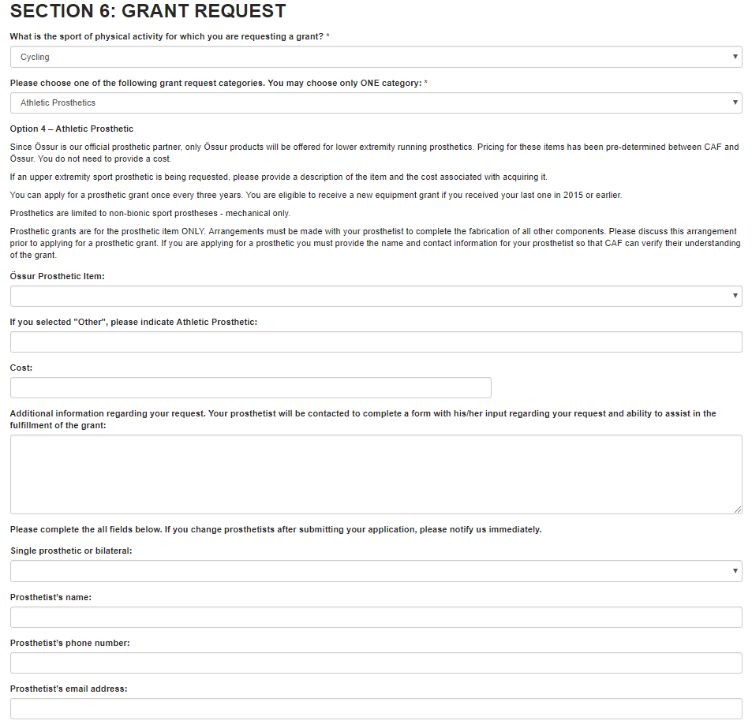If you select a Prosthetic grant, please choose your Össur prosthetic from the dropdown list.
Discuss with your prosthetist which prosthetic will best suit you.

Your prosthetist will play a key role in your application. Fill out their name, phone number, and email address in this section.

You’ll need to fill out more information in the “Additional Information Required” task on your Grant Application Portal page (skip ahead a couple of pages for step by step instructions). Once filled out, an email will be sent to your prosthetist, and they will fill out a Prosthetist Recommendation Form and email it back to the
application. Your application cannot be submitted until your
prosthetist has completed the “Prosthetist Recommendation Form”. It is the applicant’s responsibility to follow up with your prosthetist to make sure they receive the email and submit the form.

Please read this section thoroughly for more information.

Additional Information

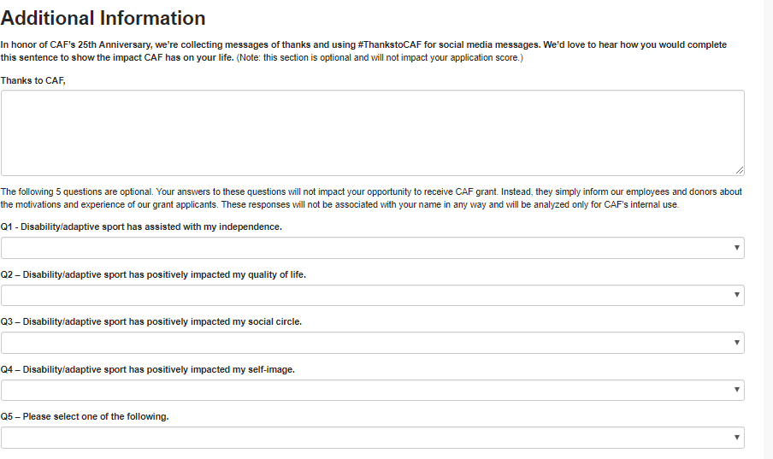
This section is optional, but appreciated. Answers will not impact your overall application score.

Statement of Affirmation

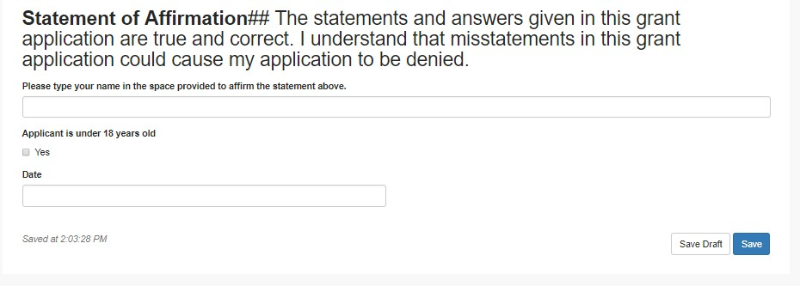

Sign, Date, and click SAVE to complete the application portion. If you want to save your application and finish it up at a later time, click SAVE DRAFT. Please note, clicking SAVE does not submit application.

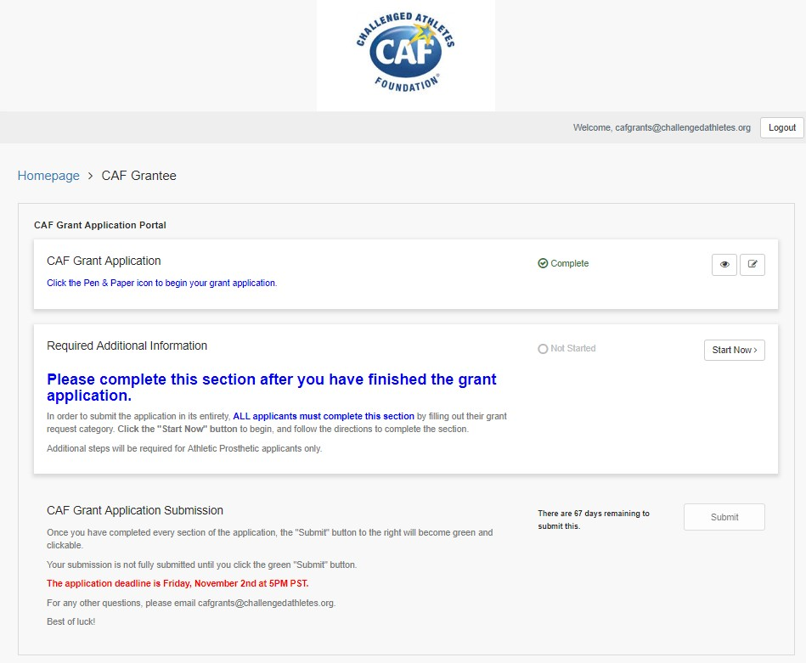Return to Grant Application Portal
You’re not quite finished yet! See next page for instructions on how to complete the “Required Additional Information” section.
Once you click SAVE or SAVE DRAFT, you’ll return to the Grant Application Portal page. If you’ve completed the entire application, you’ll see the green checkbox and the word “Complete”. If your application is in draft form, the grant application box will say “In Progress”.

Required Additional Information

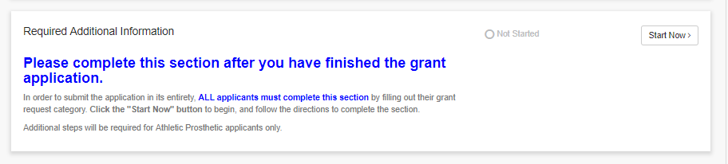
Required Additional Information: Read the instructions in the “Required Additional Information” box. This section is required for all applicants to complete, however, only applicants who requested prosthetics will be required to take additional actions.
Click the “Start Now” button to begin.
See next page for additional information.

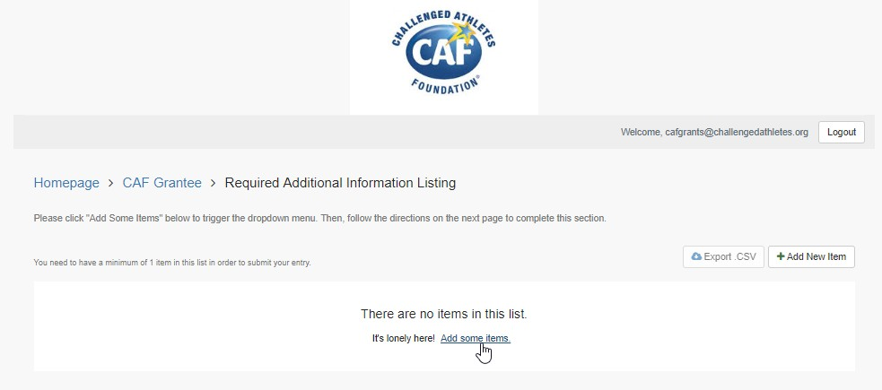
Read Instructions. Click “Add Some Items”
button at the bottom of the screen.

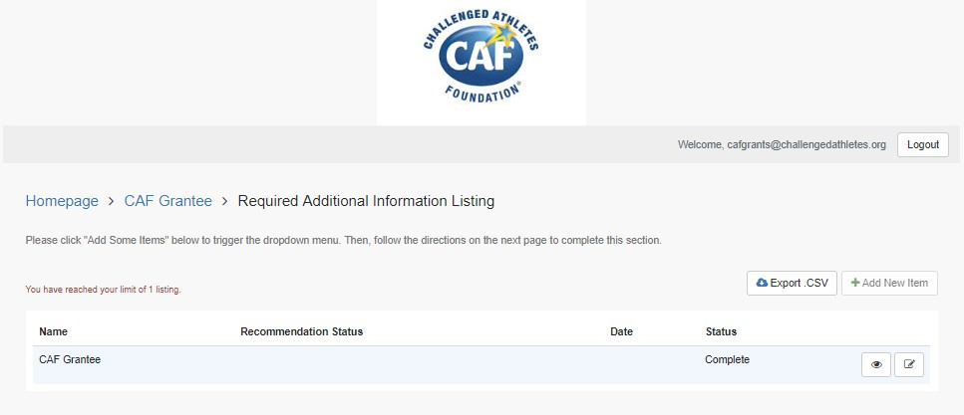Required Additional Information
If you selected “Athletic Prosthetics”, go to next page for instructions
If you selected Equipment Expenses, Coaching/Training Expenses, or Travel/ Competition Expenses, you will see the status of this task marked as “Complete”. No additional information is required, and you can click the button with the grantee’s name to return to the Grant Portal.
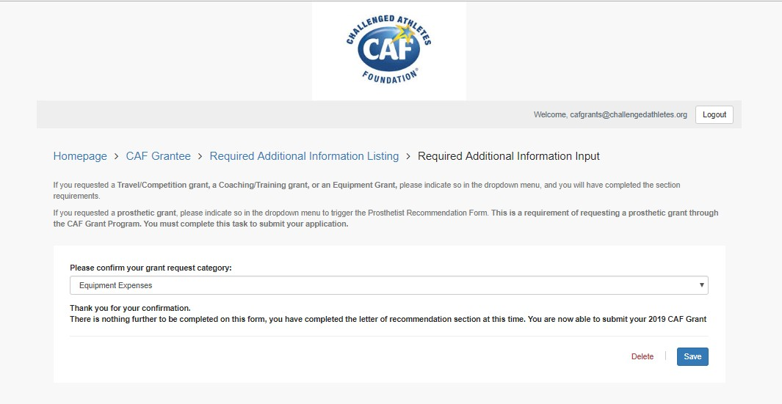Continued
Select your grant category from the dropdown list, click “SAVE” button.

Required Additional Information
Once you click “Save”, you will see the status of this task marked as “Complete”. No additional information is
required, and you can click the button with the grantee’s
name to return to the Grant Portal.
In the “Note to Prosthetist” section, we recommend typing something similar to: “Hello, I am applying for a prosthetic grant from the Challenged Athletes Foundation. Please fill out the recommendation form so that I can submit my application. I appreciate your assistance in helping me obtain this grant!”
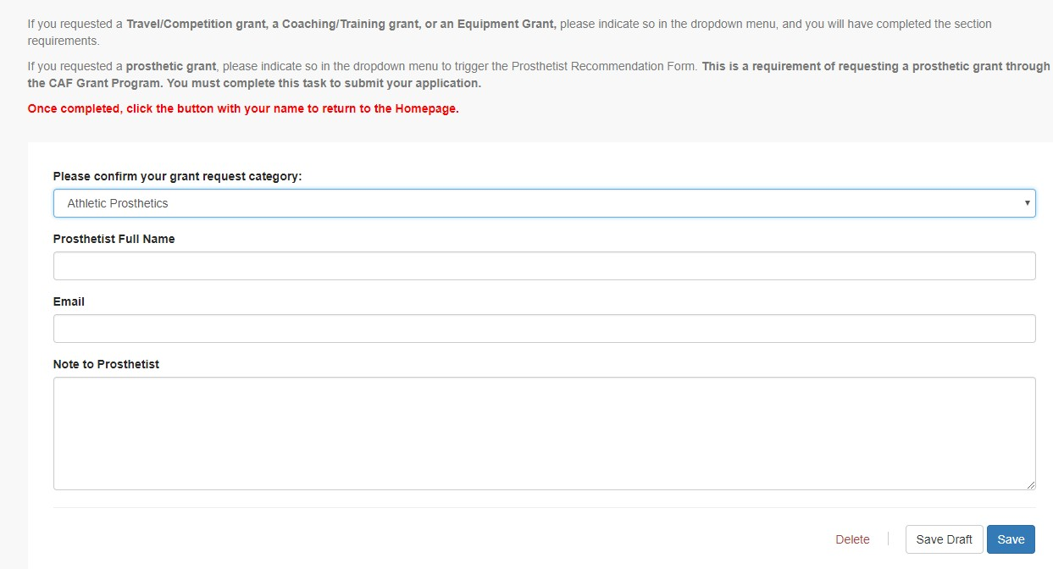Continued
If you selected “Athletic Prosthetics” as your grant request category, you’ll be prompted to fill out your prosthetist’s name and email address. Please make sure the prosthetist’s email address is accurate. By completing this mandatory task, an email will be sent to your prosthetist, and they will be asked to fill out a recommendation form.
Please follow up with your prosthetist to make sure they received the email and complete the recommendation form. Once they complete the form you will be able to submit your application.

Submission
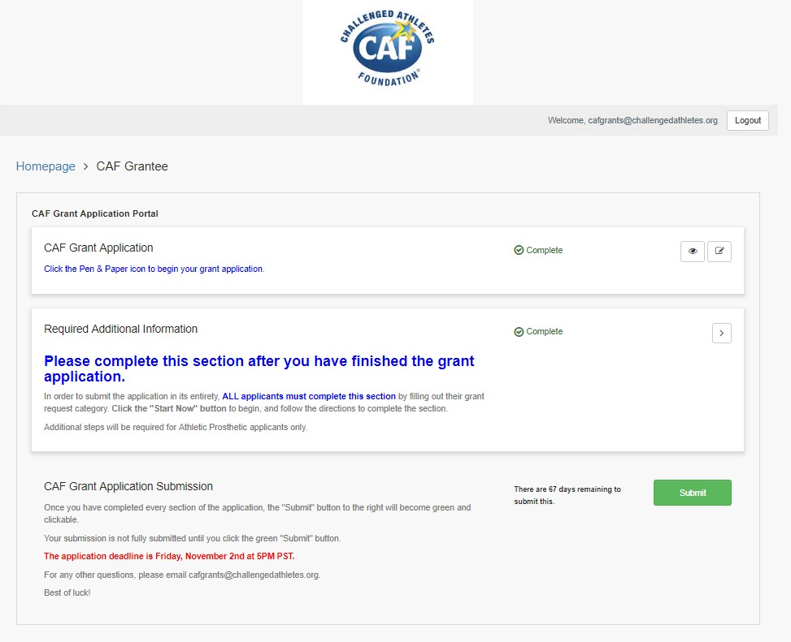
Once you have completed your CAF Grant Application AND the Required Additional Information, the “Submit” button will become green and clickable.

Please note that once you submit your application, you are not able to edit it. Click “Submit” when you are ready to turn in your 2019 grant application.

The application deadline is FRIDAY NOVEMBER 2ND AT 5 PM PST.

No late applications will be accepted!

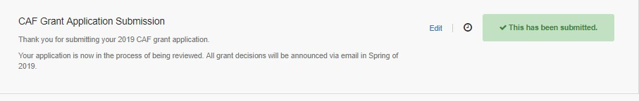
Once you’ve successfully submitted your
application, you will receive a confirmation email.

Grant applicants will be notified of the status of their grant in Spring 2019.

FAQs
Q: When will I know if I was awarded a grant?
A: ALL applicants (approved and declined) will be notified about the status of their grant in mid-March of 2019.

Q: I think I submitted my application, but didn’t receive a confirmation email. Did you receive my application?
A: If you did not receive an email stating they your application was successfully submitted, it is likely that we did not receive it. Please check your application to make sure it was submitted, and check your junk/spam folders for the confirmation email.

Q: My address changed since applying for a grant. Who do I notify?
A: Please login to your grant application and update your PROFILE with your new contact information.

Q: I can’t remember my grant application login. Can you reset my password?
A: CAF does not have the ability to reset passwords. Please contact Zengine support on the grant application website for any website errors/login issues.

Q: Can I fill out a paper application?
A: All applications must be filled out electronically online. No paper applications will be accepted.

Q: Will you accept late applications?
A: No. Applications that have not been submitted by 5PM PST on Friday, November 2nd, 2018 will NOT be accepted, and applicants will be invited to apply again next year.

Q: I have more questions. Who do I contact?

t
A: First, please read the grant FAQ page on our website, www.challengedathletes.org/grants for answers to many common questions. Please EMAIL cafgrants@challengeda
hletes.org with
other questions, and our grants team will get back to you as soon as possible. We thank you for your patience during this busy time!

