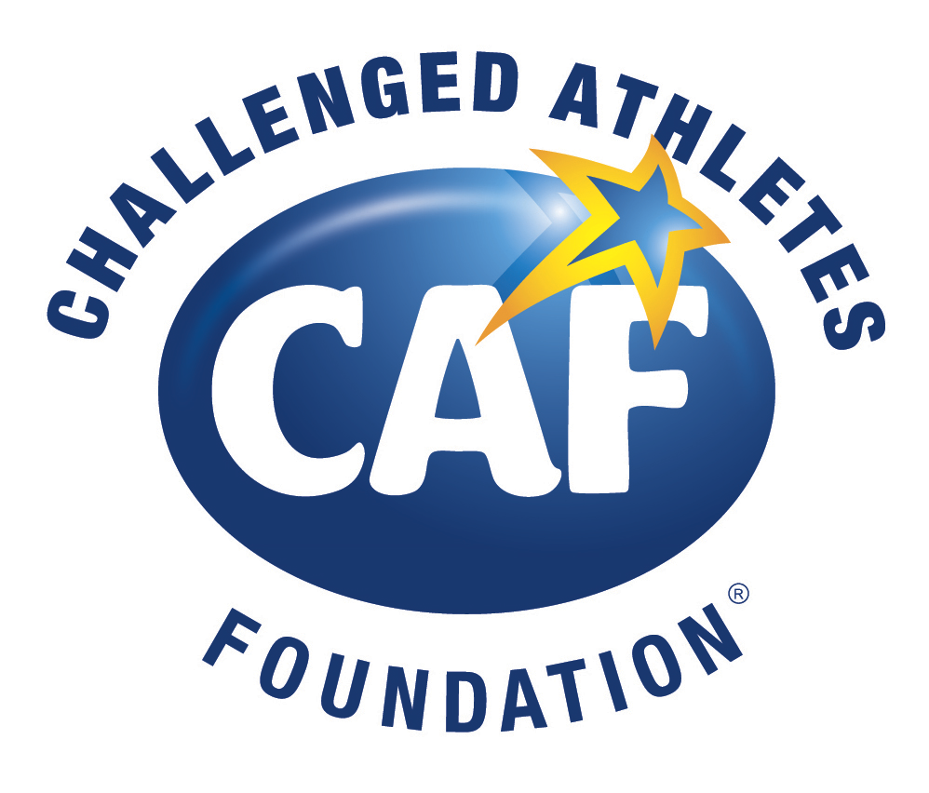
Two Challenged Athletes Race Across the Sky in Daunting Leadville Race Series

‘One Arm” Willie Stewart Attempts to be First Challenged Athlete to Earn the LEADMAN Honor; Andre Szucs Has Sights Set on First Leadville Trail 100 MTB Finish

SAN DIEGO — August 3, 2017 — Across the high-altitude, extreme terrain of the Colorado Rockies, the Leadville 100 Race Series was created for the most determined athletes. These iconic running and mountain biking races challenge participants to scale thousands of feet of elevation gain and traverse varied and sometimes impossible terrain. With the long-time support of the Challenged Athletes Foundation, Willie Stewart will strive to become the first Challenged Athlete to earn the title of Leadman, a progressive series of summer trail run and mountain bike events totaling 282.4 miles. Andre Szucs, a challenged athlete training with and mentored by Stewart, will attempt to complete his first Leadville Trail 100 MTB finish on August 12. Both Willie and Andre are racing to raise awareness and funds for the Challenged Athletes Foundation to help support more people with physical challenges by providing access to sports and physical fitness.

Stewart faces the ultimate challenge in his quest for the Leadman title. He must race a progressive series of trail run and mountain bike events ranging from 26.2 to 100 miles for a total of 282.4 miles. He has completed the Leadville Trail Marathon (June 16) and the Silver Rush 50 MTB (July 8), and now must race in rapid succession — the Leadville Trail 100 MTB (August 12), Leadville 10K Run (August 13) and the Leadville Trail 100 Run (August 19). However, Stewart is accustomed to such challenges and more. In 1980, Stewart, affectionately known as “One Arm” Willie - suffered a construction accident resulting in his arm being ripped from the socket. Because of rush hour traffic, Willie ran a mile on foot to the hospital while trying to hold his left bicep muscles in with his remaining arm.

After recuperating from the accident, Stewart became involved in the Challenged Athletes Foundation, which helps hundreds of other injured and challenged athletes just like Willie get into the world of sport. Stewart became involved in the world of endurance sports. He has won the Catalina Marathon overall, completed the IRONMAN and Xterra world championships, finished the iconic Leadville Trail 100 MTB (an elevation start of 10,000 feet) numerous times, including last year’s 9:03, and even snagged a Paralympic medal in cross country skiing.
Stewart, a resident of Boise, ID, and Szucs, from Boulder, CO, have been training together this summer in preparation for the Leadville Race Series. Both have completed the Silver Rush 50 MTB and the recent two-day Leadville RECON Camp. Szucs also raced the Wilmington Whiteface qualifier ride in June. More than just a race for either individual, the team Stewart and Szucs are helping create a culture of inclusion and showing the world what’s possible when we come together and take action.
Born without the lower leg on his right side and only four fingers, Szucs grew up immersed in sports. Szucs began his career as a swimmer on the Brazilian Paralympic Swim Team and went on to compete in Ironman Brazil in 2007 where he placed 2nd in his division. Andre has also made consecutive appearances at the ITU Triathlon World Championships in 2009 and 2010. In 2011, Andre competed in the Ironman World Championships in Kona. He continues to compete in running, cycling, and triathlon events around the world, and now has his sights set on attending his third Xterra World Championships.
“One of the wonders of the world for Mountain Bikers is the Leadville 100 MTB. It has been on my bucket list for a while and I am grateful to join the team from the Challenged Athletes Foundation (CAF),” said Szucs. “I have been training harder and smarter than ever before - learning to better manage technical trails, exploring new places and higher altitudes, and sharing my experience with so many others to help raise awareness and money for CAF.”

About Leadville Race Series
Started with only 45 runners as the Leadville Trail 100 in 1983, the Leadville Race Series now consists of six running events, the Leadville Trail 100 mountain bike race, and six mountain biking events in the Leadville Qualifying Series. The Race Series stretches across three months, and hosts thousands of racers on foot and on mountain bike in some of the world’s most iconic events. Endurance athletes worldwide now make the pilgrimage to Leadville, Colo., with the single goal of competing in “The Race Across the Sky.” Visit www.leadvilleraceseries.com for more information.

About the Challenged Athletes Foundation
The Challenged Athletes Foundation® (CAF) is a world leader in helping people with physical challenges lead active, healthy lifestyles. CAF believes that participation in physical activity at any level increases self-esteem, encourages independence and enhances quality of life. Since 1994, more than $80 million has been raised and over 15,000 funding requests from people with physical challenges in all 50 states and dozens of countries have been satisfied. Additionally, CAF’s outreach efforts reach another 60,000 individuals each year. Whether it’s a $2,500 grant for a handcycle, helping underwrite a carbon fiber running foot not covered by insurance, or arranging enthusiastic encouragement from a mentor who has triumphed over a similar challenge, CAF’s mission is clear: give opportunities and support to those with the desire to live active, athletic lifestyle. To learn more, visit challengedathletes.org or call 858-866-0959.

# # #

