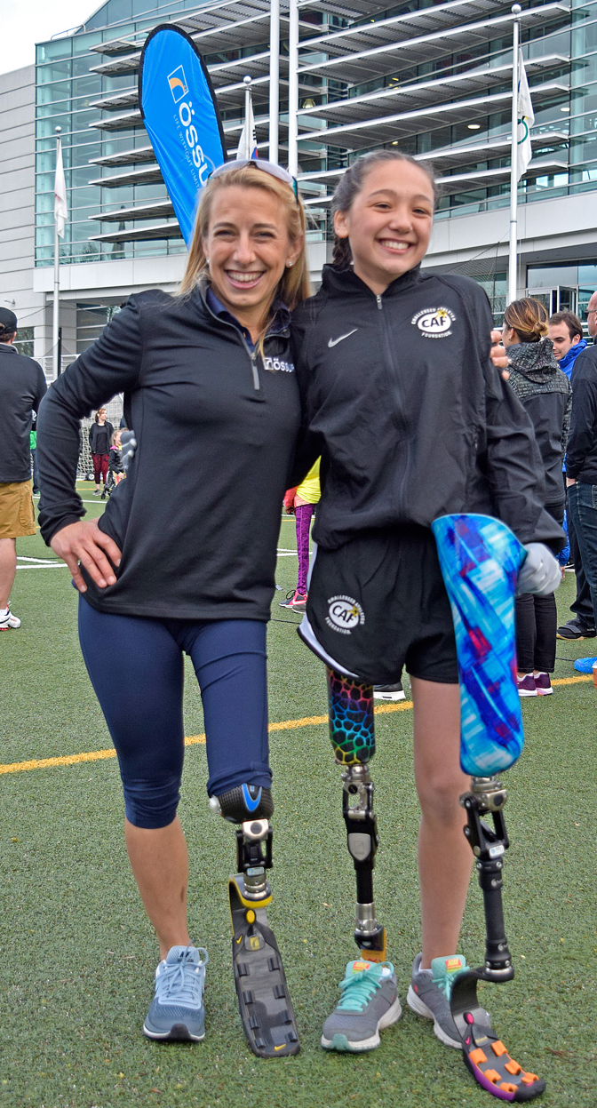 | Contacts:  Nancy Reynolds  619.318.6012  nancy@challengedathletes.org  Össur Media Contact  Elizabeth Vanderweerd  949.282.4748  evanderweerd@ossur.com  Nike Media Contact  Greg Rossiter  503.671.2682  greg.rossiter@nike.com
PORTLAND CHALLENGED ATHLETES COME TO NIKE WORLD HEADQUARTERS TO DEVELOP LIFE CHANGING SKILLS THROUGH SPORT; CAF RECEIVES $200,000 GRANT DONATION FROM NIKE

Nike, Challenged Athletes Foundation (CAF) and Össur host the Össur Running and Mobility Clinic, CAF Swim, CAF Sitting Volleyball and CAF Wheelchair Basketball Clinics Held on April 8, 2017

Beaverton, Ore. – April 10, 2017 – The Challenged Athletes Foundation (CAF) announced it has received a grant donation of $200,000 from Nike. The grant will support athletes with permanent physical challenges by facilitating relationships with organizations in their communities, providing incentives for athletes to stay active, and establishing a mentorship program. CAF and Nike have had a long-standing partnership for many years prior to today’s announcement, dating back to 1994.

This announcement coincided with the third annual all-day sport clinic at Nike World Headquarters in Beaverton, Oregon on Saturday, April 8, which included a special grant presentation of a new custom-built Össur Flex-Run foot with Nike Sole to 12- year old Adelynn Klundby, from North Powder, Ore., that she tested during day. Adelynn was born with PFFD (Proximal Femoral Focal Deficiency) which is having one “short leg.” Adelynn attended an Össur Running and Mobility Clinic Presented by CAF at Nike in 2015 where she met Sarah Reinertsen who is a Nike athlete, CAF and Össur spokesperson and mentor to many others who face similar challenges.

Thanks to partner Adaptive Sports Northwest (ASNW), along with our amputee participants, all local wheelchair athletes also participated in three other CAF clinics: Swim Clinic, Sitting Volleyball and Wheelchair Basketball, that were led by the USA assistant men’s national team coach and one gold medal winning athlete from each of the men’s and women’s teams.

CAF Executive Director, Virginia Tinley said, “These clinics and our efforts to support challenged athletes are so much stronger together. We believe that our partnership with Össur, Nike, ASNW and other community resources will provide these athletes with what they need to succeed and make them and their community whole through sports”.

Along with CAF, Nike partnered with Össur to create the Sarah Sole, which is provided with Össur prosthetic running legs. At this past weekend’s clinic, athletes received instruction from Össur world-renowned coaches in lower limb amputee mobility: Dr. Bob Gailey and Peter Harsch, taught proper running form and technique through fun drills and exercises. These athletes were supported by local volunteers including Nike employees and Össur and CAF mentors.

“We are pleased to be offering another Össur Running and Mobility Clinic presented by CAF on Nike’s campus again this year. Each year, we host a number of Clinics like this across the nation, and they continue to grow in size and scale. We are inspired by Adelyn and her peers, and continue in our dedication to pioneer innovations that can help even more people enjoy life without limitations,” said Kim De Roy, CPO/PT, Vice President of Sales & Marketing and Education, Prosthetics for Össur Americas

“We continue to be inspired by the athletes that the Challenged Athletes Foundation helps us bring together through sport. Our hope is that this grant allows even more individuals to experience the barrier-breaking power that sport has to offer,” said Tommy Kain, VP, Strategic Planning and Operations, and member of Nike’s Ability* Network.

Nike believes in the inspirational power of sport to break down barriers, overcome differences and bring people together. Nike also believes in creating teams that truly reflect the diversity of its consumers and a culture of inclusivity that respects the communities in which its employees live and work. By fostering inclusion and embracing diversity throughout the company, Nike becomes closer to its consumers, empowers its employees to realize their full potential and creates breakthrough innovations for athletes.

About Challenged Athletes Foundation
Challenged Athletes Foundation® (CAF) is a world leader in helping people with physical challenges lead active, healthy lifestyles. CAF believes that participation in physical activity at any level increases self-esteem, encourages independence and enhances quality of life. Since 1994, more than $80 million has been raised and funded over 15,000 grant requests from people with physical challenges in all 50 states and dozens of international countries. Additionally, CAF’s outreach efforts reach another 60,000 individuals each year. Whether it’s a $2,500 grant for a handcycle, helping underwrite a carbon fiber running foot not covered by insurance, or arranging enthusiastic encouragement from a mentor who has triumphed over a similar challenge, CAF’s mission is clear: give opportunities and support to those with the desire to live active, athletic lifestyles. To learn more, visit challengedathletes.org and follow @cafoundation.

About Össur
Össur (NASDAQ: OSSR) is a global leader in non-invasive orthopaedics that help people live a life without limitations. Its business is focused on improving people’s mobility through the delivery of innovative technologies within the fields of Prosthetic, Osteoarthritis and Injury Solutions. A recognized “Technology Pioneer,” Össur invests significantly in research and product development—its award-winning designs ensuring a consistently strong position in the market. Successful patient and clinical outcomes are further empowered via Össur’s educational programs and business solutions. Headquartered in Iceland, Össur has major operations in the Americas, Europe and Asia, with additional distributors worldwide. To learn more, visit www.ossur.com.

About Nike
NIKE, Inc., based near Beaverton, Oregon, is the world's leading designer, marketer and distributor of authentic athletic footwear, apparel, equipment and accessories for a wide variety of sports and fitness activities. Wholly owned NIKE, Inc. subsidiaries include Converse Inc., which designs, markets and distributes athletic lifestyle footwear, apparel and accessories; and Hurley International LLC, which designs, markets and distributes surf and youth lifestyle footwear, apparel and accessories. For more information, NIKE’s earnings releases and other financial information are available at http://investors.nike.com. Individuals can also visit http://news.nike.com/ and follow @Nike.

# # #

